***html project report***

***Name***: **Mostafa Ahmed Abd *Elhmed***

**الأسم : مصطفى أحمد عبد الحميد على**

**B/N : 908**

**رقم الجلوس : ٩٠٨**

**Date : 6/5**

## **Topic : Programming Languages**

**About programming languages**

**What are the benefits of programming and programming languages**

​​(the concept of programming).

Programming concept: It means allocating a specific practical system with certain laws and regulations within a specified framework.

Programming or technical software: It is intended to create a working system specified in one of the programming languages ​​that the machine understands to perform a specific function.

Programming languages: They are languages ​​created by humans to facilitate communication with machines, determine their work and send them commands in an easier way.

Programmer: is the student who writes codes and develops programs to develop practical solutions or write the programming language in the form of commands to obtain the required program, and programming has sections and languages ​​that need education.

**The importance of programming in our lives**.

Programming has become intrusive into all of our lives and technology, as well as nowadays, the number of things that depend on programming cannot be listed. Without a doubt, if the world abandons programming, all the technical civilization that we are witnessing today will disappear. Programming interferes with the manufacture of everything that is digital, for example, phones, television, computers and many industrial machines.

To understand my purpose more, you can compare the programming languages ​​with English, for example, or any language other than your mother tongue. As an Arab, can I deal with a foreigner without learning his language? Can we understand each other? Of course not. Likewise, neither God nor the computer can understand us without a language understandable to both of us “I mean its concept for humans and for God.” Therefore, programming must exist until we program machines.

**Explain the importance of programming around us**

To introduce the importance of programming in computers and mobile phones, for example, in the field of my work "electrical engineering" we use programming to direct machines to lift heavy equipment or to use motors, as well as in alarm devices and many uses.

Programming is also included in the medical field and examinations. Medical devices are an introduction that is programmed by programmers to make it easier for doctors to use.

Also, in the military and defense fields, programming is used to guide missiles and others.

Programming is also included in the technology for the manufacture of intelligent robots and the development of artificial intelligence.

You also find programming in the development of smart phone applications. In your Android or iOS phone, you will find the applications that you use on a daily basis. Programming has been relied upon in their development.

In the regulation of traffic, navigation and control of various devices.

It is also used in many industries around us. You will not find a single factory or a machine that works automatically without a software part.

Now I think you have come to realize that programming is important in various different areas of life.

**Programming uses**.

You may ask about the uses of programming, and I will answer you simply about its use briefly and succinctly:

It is used in the medical fields and the machines available in hospitals such as cardiac examination machines and others.

It is also used in smart phones in terms of the operating system, it has been pre-programmed, as well as in applications that work on the phone.

Among the uses of programming in building web pages and websites that you browse daily on your phone, Facebook is a website built with programming.

The computer programs that you use on a daily basis were programmed using programming as well.Operating systems such as Mac, Windows and Linux.

It is used in a variety of other fields such as "military industries – medical devices – industrial machines and many others

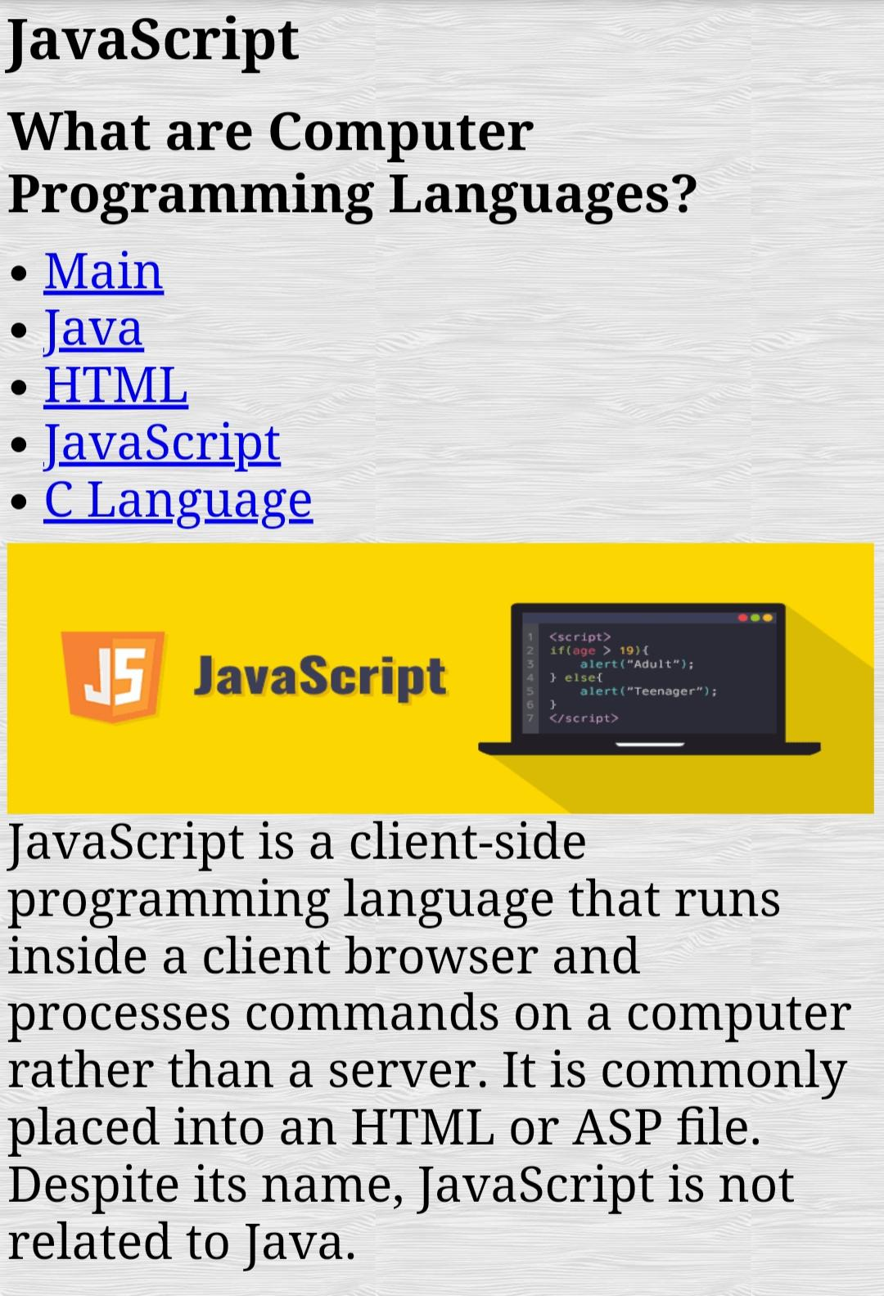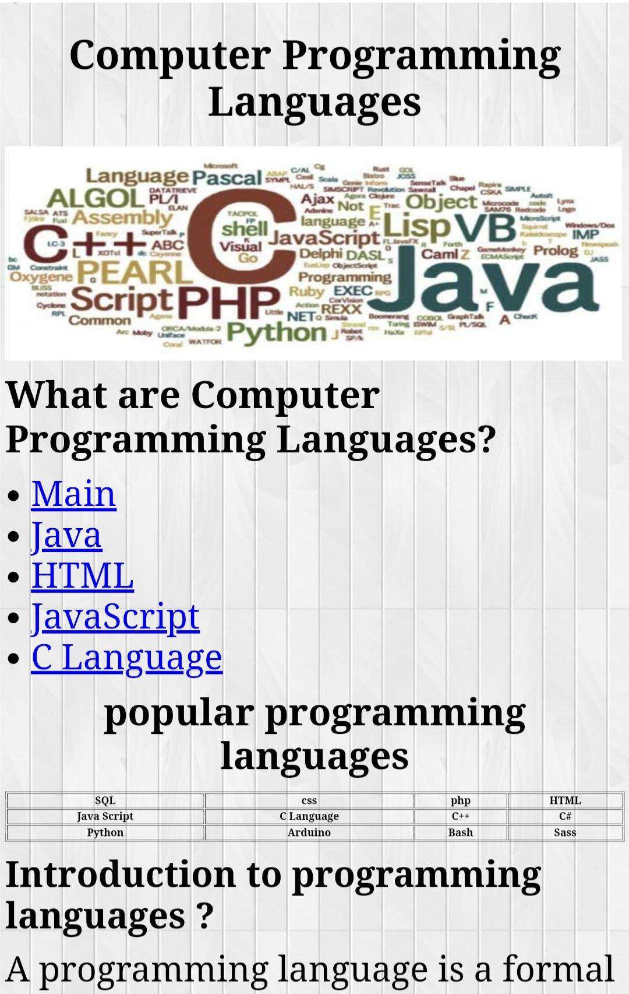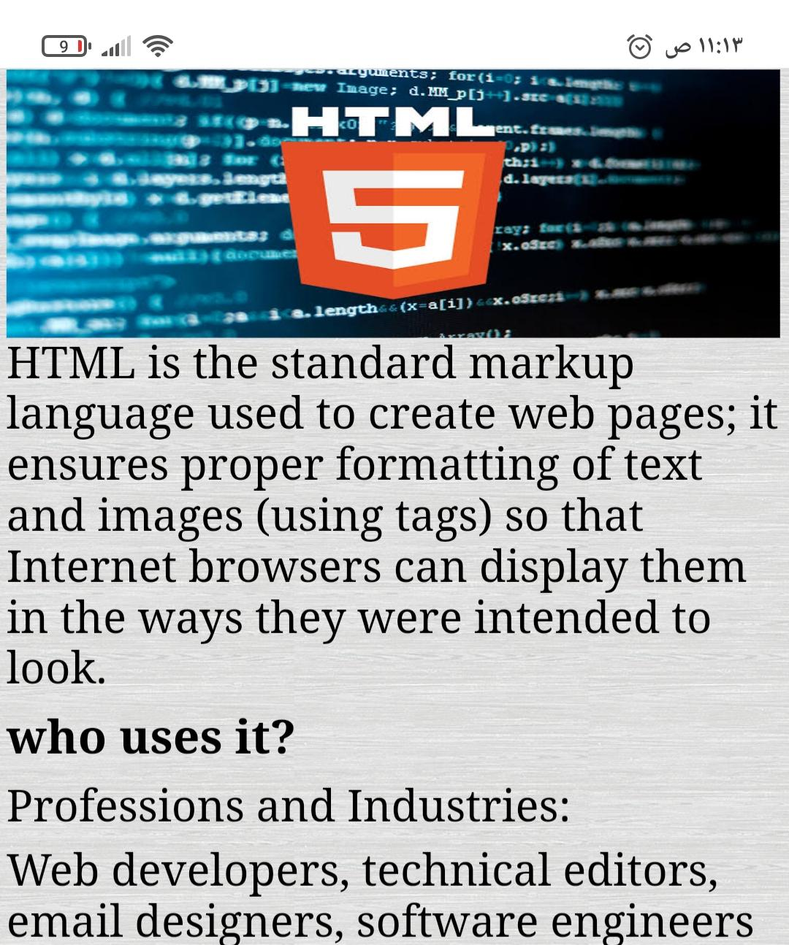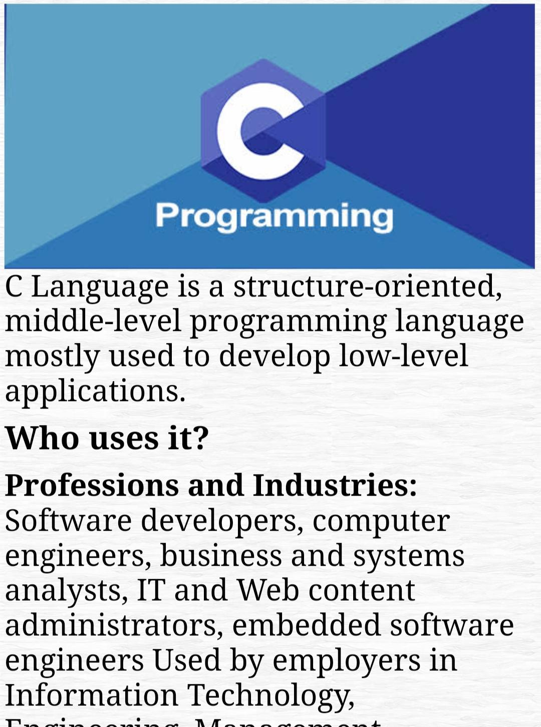**Screenshot**

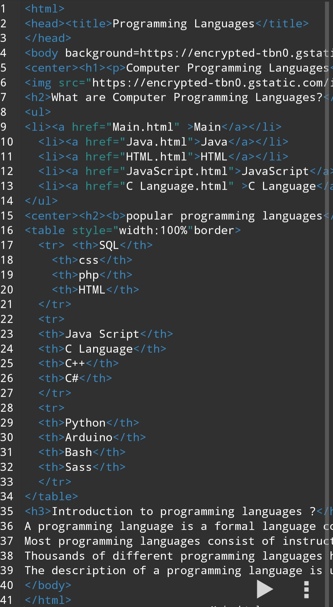**source code:**